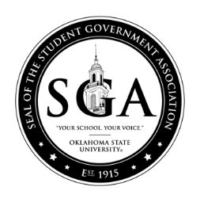

OKLAHOMA STATE UNIVERSITY STUDENT GOVERNMENT ASSOCIATION
STUDENT BODY SENATE
FALL 2021

Bill: F21BLXXX
Date: XX/XX/XX
Committee:

AS INTRODUCED

A bill amending the process of elections outlined in Title X; providing for short title, providing for an effective date.

BE IT ENACTED BY THE STUDENTS OF OKLAHOMA STATE UNIVERSITY THAT:

Section 1: AMENDATORY (if amending current law) or NEW LAW (if creating new law): The following is to be amended to XXXXXXX:

Section 2: Upon passage and approval, the Attorney General is hereby directed to update the By-laws to reflect these changes.

Section 3: This bill shall be forwarded to:

Jack A. Edwards, Student Body President
Alexandria Bias, Student Body Vice President
Nathan Dethloff, SGA Senate Chair
Dr. John Mark Day, SGA Advisor; Director of Leadership and Campus Life
Melisa Echols; Coordinator of SGA Programs

Author(s):

Co- Author(s)

Sponsor(s):

