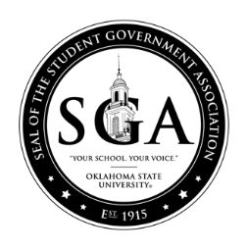

OKLAHOMA STATE UNIVERSITY STUDENT GOVERNMENT ASSOCIATION
STUDENT BODY SENATE
FALL 2018

Bill: F18BLXXX
Date: XX/XX/XX
Committee:

AS INTRODUCED

A bill amending the process of elections outlined in Title X; providing for short title, providing for an effective date.

BE IT ENACTED BY THE STUDENTS OF OKLAHOMA STATE UNIVERSITY THAT:

Section 1: AMENDATORY (if amending current law) or NEW LAW (if creating new law): The following is to be amended to XXXXXXX:

Section 2: Upon passage and approval, the Attorney General is hereby directed to update the By-laws to reflect these changes.

Section 3: This bill shall be forwarded to:

Chase Blevins, SGA President
Vanessa Wiebe, SGA Vice-President
Holland Gray, SGA Senate Chair
Dr. John Mark Day, SGA Advisor; Director of Leadership and Campus Life
Melisa Echols, Coordinator of SGA Programs

Author(s):

Co- Author(s)

Sponsor(s):

