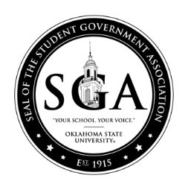

OKLAHOMA STATE UNIVERSITY STUDENT GOVERNMENT ASSOCIATION
STUDENT BODY SENATE
FALL/SPRING 2021

Senate Recommendation or Resolution: F21RCorRSXXX
Date: XX/XX/XX
Committee:

AS INTRODUCED

A resolution or recommendation doing said activity; and providing for forwarding:

Whereas:

Whereas:

Whereas:

THEREFORE, BE IT RECOMMENDED or RESLOVED BY THE OKLAHOMA STATE UNIVERSITY STUDENT GOVERNMENT ASSOCIATION (SENATE if resolution) THAT:

Section 1:

Section 2: This bill shall be forwarded to:

Jack A. Edwards, Student Body President
Alexandria Bias, Student Body Vice President
Nathan Dethloff, SGA Senate Chair
Dr. John Mark Day, SGA Advisor; Director of Leadership & Campus Life
Melisa Echols: Coordinator of SGA Programs

Author(s):

Co- Author(s)

Sponsor(s):

