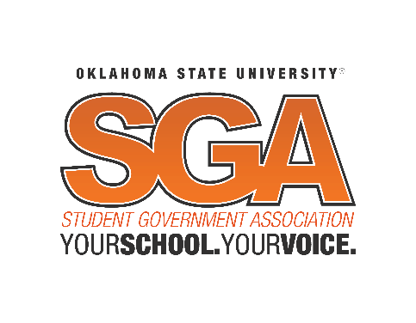

Student Body Senate Agenda
Wednesday, Month Day, Year at 7:00pm
Student Union, Case Study 2

- Call to Order of the Student Body Senate of the Student Government Association of Oklahoma State University
- Roll Call
- Joint session Initiation
  - Appointment of Sergent at Arms
  - Invitation to Executive Branch
  - Roll Call of Executive Branch by SGA Vice President
    - Vanessa Wiebe
  - Invitation to Judicial Branch
  - Roll Call of Judicial Branch by SGA Chief Justice
    - Preston Lewis
- Joint Session call to order
  - Speakers
    - Chase Blevins, SGA President
    - Burns Hargis, University President
    - Dr. Lee Bird, University Vice President
- Adjournment

This agenda shall not be construed as preventing: The introduction of new legislation not listed, the reconsideration of any motion of the immediately preceding Senate meeting, or any regular procedural motion or any motions by an appropriate majority which allows the introduction and final consideration of Legislation in the same meeting so long as that legislation is listed in this agenda. Posted at 5:00pm on 9/18/18 by Holland Gray, Student Body Senate Chair (sgasenate@okstate.edu) 405-744-7555

