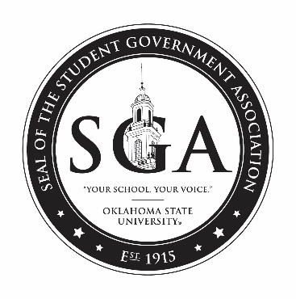

Joint Session Agenda
Tuesday, August 27, 2019 at 7:00pm
Student Union, Case Study 2

- Call to Order and Welcome

- Roll Call of Senate

- Appointment of Sergeant at Arms

- Introductions

- Roll Call of Executive Branch

- Address by Senate Chair

- Address by University President

- Address by Student Body President

- Closing Ceremony

