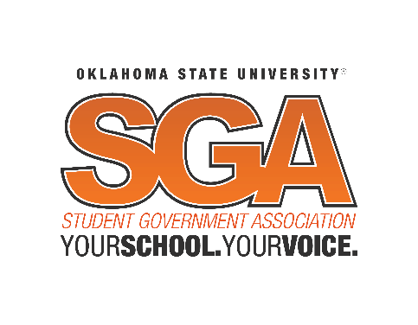

Student Body Senate Agenda
Wednesday, April 24, 2019 at 7:00pm
Student Union, Case Study 2

- Call to Order of the Student Body Senate of the Student Government Association of Oklahoma State University
- Roll Call
  - Swearing in of New Senators, Supreme Court Justices, and Executives:
“I, state your name, do solemnly affirm that I will discharge to the best of my ability, the responsibilities entrusted to me, as an officer of the Student Government Association of Oklahoma State University”
- Pledge of Allegiance
- Approval of Minutes of the Previous Meeting
  - April 17, 2019
- Suspension of Senate Rules for modified agenda
  - Modified Consent Calendar Rules:
    - 3 Minutes for authors explanation
    - 4 Minutes for questions
    - No debate.
    - Will pass with unanimous consent unless objected to; in which case it goes to roll call vote.
  - Election Structure Rules:
    - Chair:
      - 4 Minute Speech
      - 10 Minute discussion with ability to extend time only once.
    - Vice-Chair
      - 3 minute Speech
      - 7 minutes for discussion with ability to extend time only once.
    - Committee Chairs
      - 1.5 Minute speeches
      - 6 Minutes for discussion with no ability to extend time
- Guest Speakers and Student Concerns
  - Dr. Doug Hallenbeck, Vice President of Student Affairs
- Advisor(s) Report – Coordinator Melisa Echols
- Unfinished Business
  - Modified Consent Calendar Rules:
    - S19BL020: A bill providing co-sponsorship funds to the International Student Organization.
    - S19BL028: A bill to grant registered status to Cars and Cowboys.
- New Business
  - Regular Order:
    - S19RC001: A recommendation to Oklahoma State University to adopt one Student Response System (Clicker).
  - Modified Consent Calendar Rules:
    - S19BL030: A bill to grant registered status to the Student Center for the Public Trust.
    - S19BL031: A bill to grant registered status to Freedom by Design (FBD).
    - S19BL032: A bill to grant registered status to Parker Engineering Architecture Technology Experts (PEATE).
    - S19BL033: A bill to grant registered status to Women Inspired by Leadership and Diversity (W.I.L.D.).
    - S19BL035: A bill to grant registered status to Best Buddies Oklahoma State University (OSU).
  - Regular Order
    - S19BL029: A bill establishing the SGA Operating Budget and establishing Budgetary Guidelines.
    - S19RS007: A resolution to confirm the nominated members of the Oklahoma State University Executive Cabinet.
    - S19BL026: A bill amending Title II: Introducing a position of Food Insecurity Director.
    - S19BL025: A bill amending Title II: Introducing a position of It’s On Us Director.
    - S19BL034: A bill reforming elections outlined in Title X, and amending Title III
      - RESOLVE INTO COMMITTEE OF A WHOLE
    - S19BL036: A bill amending the duties of the Vice-President outlined in Article II of the Student Government Association Constitution.
- Recess for Legislation to be Forwarded to Committees
- Executive Reports
  - Cabinet Executives
- Supreme Court Report(s)
- Senate Reports
  - Committee Chairs
    - Budget – Jessie Hickey
    - CSO – Mason Martin
    - Internal Affairs – Noah Murphey
    - PAC – Zach Kensinger
    - University – Stephanie Rojo
  - Constituency Reports
  - Senate Elections
    - Chair
      - Nominations
        - Marcus Heald
        - Noah Murphey
    - Vice Chair
      - Nominations
        - Joshua Fisher
        - Michael Albright
        - Noah Murphey
        - Callie Dumbauld
    - Committee Chairs
      - Budget
        - Nominations
          - Ashley Schultz
      - CSO
        - Nominations
          - Logan Hutto
      - Internal Affairs
        - Nominations
          - Noah Murphey
          - Aaron Carmichael
      - PAC
        - Nominations
          - Samuel Smith
      - University
        - Nominations
          - Luke Muller
          - Kylie Dowers
          - Lauren Smith
- Vice President’s Report- Vanessa Wiebe
  - Farewell
- President’s Report- Chase Blevins
  - Farewell
- Vice Chair’s Report – Jaden Kasitz
  - Farewell
- Chair’s Report – Holland Gray
    - Senator Superlatives
    - Farewell
- Announcements
- Informal Discussion
- Adjournment

This agenda shall not be construed as preventing: The introduction of new legislation not listed, the reconsideration of any motion of the immediately preceding Senate meeting, or any regular procedural motion or any motions by an appropriate majority which allows the introduction and final consideration of Legislation in the same meeting so long as that legislation is listed in this agenda. Posted at 6:00pm on April 23, 2019 by Holland Gray, Student Body Senate Chair (sgasenate@okstate.edu) 405-744-7555

