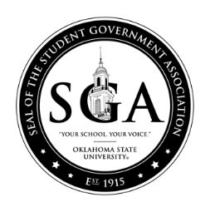

Student Body Senate Agenda
Wednesday, April 8, 2020 at 7:00pm
Student Union, Case Study 2

- Call to Order of the Student Body Senate of the Student Government Association of Oklahoma State University
- Roll Call
  - Swearing in of New Senators, Supreme Court Justices, and Executives:
“I, state your name, do solemnly affirm that I will discharge to the best of my ability, the responsibilities entrusted to me, as an officer of the Student Government Association of Oklahoma State University”
- Pledge of Allegiance
- Approval of Minutes of the Previous Meeting
  - April 1, 2020
- Guest Speakers and Student Concerns
- Advisor(s) Report – Dr. John Mark Day/Melisa Echols
- President’s Report- Kaitlyn Kirksey
- Vice President’s Report- Kristen Ball
- Floor Speeches
- Unfinished Business
- New Business
  - S20BL036: A bill to grant registered status to Cowboy Space Program.
- Recess for Legislation to be Forwarded to Committees
- Executive Reports
  - Cabinet Executives
- Supreme Court Report(s)
- Senate Reports
  - Committee Chairs
    - Budget – Ashley Schultz
    - CSO – Logan Hutto
    - Internal Affairs – Aaron Carmichael
    - PAC – Noah Mead
    - University – Luke Muller
  - Constituency Reports
  - Other Senate Reports
    - Liaisons
    - Representatives
      - Board of Regents for A&M Colleges – Nathan Dethloff
      - Board of Regents for Higher Education – Logan Hutto
      - Faculty Council – Ashley Schultz
  - Vice Chair’s Report – Noah Murphey
  - Chair’s Report – Marcus Heald
- Announcements
- Informal Discussion
- Adjournment

This agenda shall not be construed as preventing: The introduction of new legislation not listed, the reconsideration of any motion of the immediately preceding Senate meeting, or any regular procedural motion or any motions by an appropriate majority which allows the introduction and final consideration of Legislation in the same meeting so long as that legislation is listed in this agenda. Posted at 7:00pm on April 7, 2020 by Marcus Heald, Student Body Senate Chair (sgasenate@okstate.edu) 405-744-7555

