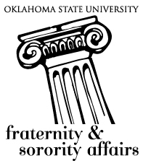
Outstanding Advisor Award Nomination Sheet
2016

The Outstanding Advisor Award was created by Order of Omega to recognize and celebrate the hard work of local chapter advisors and the contributions they make to the fraternity and sorority community at Oklahoma State University.

The award is not limited strictly to persons with the title of “chapter advisor,” but is open to recruitment advisors, alumni advisors, house directors, house corporation advisors, or any alumni who have contributed significantly to the success of their chapter at OSU through their current service.

To nominate an advisor for this award, please submit a letter of recommendation explaining why he/she deserves this award. Nominations are due January 29, 2016, to the Office of Fraternity & Sorority Affairs in 211J Student Union by 4:30 p.m.

