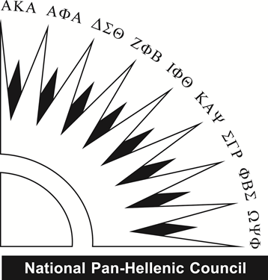
Please complete this form if you are interested in receiving more information about joining a National Pan-Hellenic Council fraternity or sorority. This interest form will be distributed to the organizations in which you indicate interest.
Name: ____________________________________________ Phone Number: ________________
Address: ___________________________________________________________________________
Email: ______________________________________________________________________________
Classification: ____________________ HS GPA:______________ Cumulative GPA: _______________
Please circle the organization(s) you are interesting in joining. Chapter specific information can be found at http://union.okstate.edu/NPHC/
Alpha Phi Alpha Fraternity, Inc.
Kappa Alpha Psi Fraternity, Inc.
Omega Psi Phi Fraternity, Inc.
Delta Sigma Theta Sorority, Inc.
Phi Beta Sigma Fraternity, Inc.
I authorize the National Pan-Hellenic Council to verify and share my academic records for membership intake purposes.
________________________________ ______________________
Signature Date
Please return this form to:
Office of Fraternity & Sorority Affairs
211J Student Union
Stillwater, OK 74078
gogreek@okstate.edu

